**Rii mini V3 HOT!**

The Rii mini V3 is perfectly compatible with computers, notebooks, Smart TVs and all plug and play applications. Palm sized in design, it’s easy to hold and pocket friendly! It has a built-in back light LED and laser pointer, so you can even work/play in the dark!

The V3 delivers multi-application and is simple to use. Hard ABS material ads durability and control perfection to the keyboard feel.

The convenient navigation design offers operational distanc of 10m. Qwerty keyboard design makes surfing the net and gaming easy.

USB Plug and Play

2.4G Wireless Connection

Plug and play/random pairing

Long distance laser pointer

Backlight LED

High performance touchpad

Durable battery life

20 day fully charged battery standby

Battery charge cable included

Multi terminal compatibility

High performance touchpad 2.4G Wireless Connection

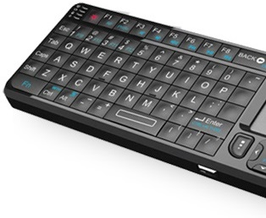 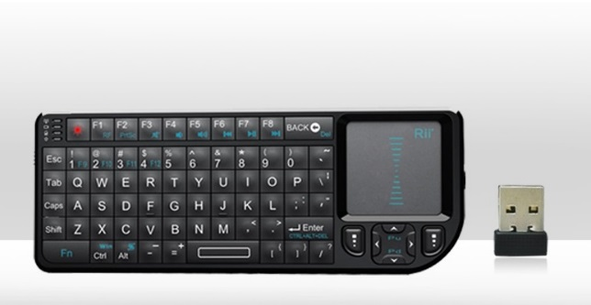

USB Plug and Play

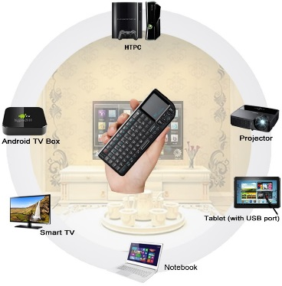

**Rii mini i8+ HOT!**

The eye-catching mini Rii i8+ is the ultra slim mini keyboard with a touchpad boasting a notebook performance replacing the traditional mouse. With USB plug and play simplicity and is compatible with all desktop computers, notebooks, smart TV’s Android TV Box and HTPC with with no manual drivers required.

Multi-touch

Percet replacement for the traditional mouse and protects you from Carpal Tunnel Syndrome.

Battery saving sends the keyboards lithium battery to sleep mode when not in use. Plug-in re-chargeable cable included.

Rubber panels resist slipping.

Advanced transmission technology

10M transmission distance

Powerful 2.4G wireless technology

Easy recharge cable

Unique size: 147mm x 97mm x 18mm thickness!

20 Days standby time when fully charged

Pocket sized and super powered

More fun to get your hands on!

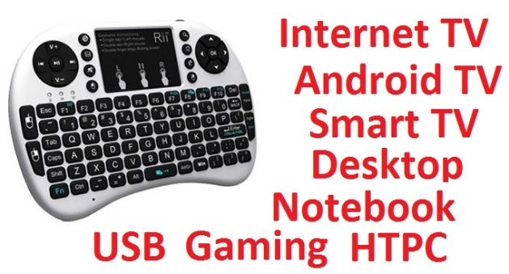 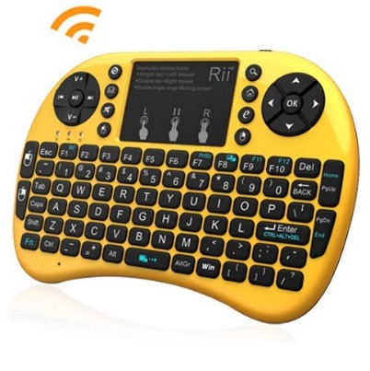

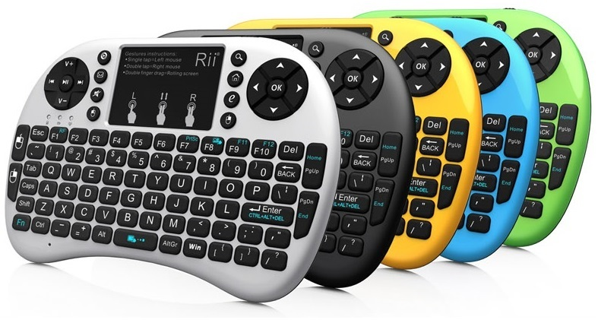

**Rii mini i10**

The Rii mini i10 is a mini wireless keyboard with plug and play USB receviers, compatible with desktop computers, notebooks and Smart TVs.

Perfect control

Wireless transmission distance reaches 10M giving you easy control from an ergonomic design.

Big screen projection

This keyboard has a built in laser pointer which can be used in multimedia presentations, meetings, lectures etc. This is an easy to use mini keyboard that allows easy interaction and total control with the screen and an audience.

Laser pointer activated with a single button

Arc-shaped base gives easy and comfortable grip

Powerful and reliable wireless connection

Durable battery, easy re-charge

High performance touchpad

Plug and play easy usage.

154mm x 63mm x 13mm thickness

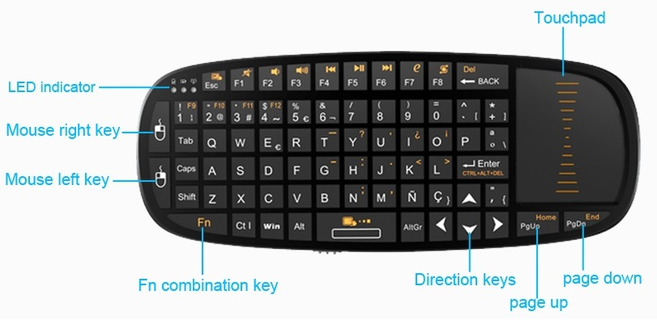

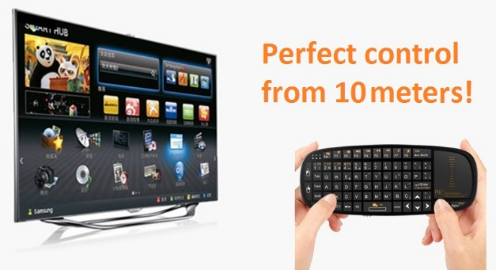 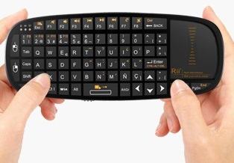

**Rii mini i12**

The Rii mini i12 is an ultra-thin mini wireless mouse combo with plug and play USB receiver. No manual driver installation is required and is compatible with desktop computers, notebooks and Smart TV, Android TV and HTPC.

Touch perfection

The keyboard touchpad functions as well as a notebook touchpad. Single finger function as left key and double finger function as right key makes interaction easy.

Chocolate keyboard with tightly aligned keys and a quieter key stroke action.

Chocolate keys seem to float! Accurate and comfortable to the touch, the keyboard is a pleasure to use.

Mini plug and play USB receiver is hidden when not in use.

Smooth brushed aluminum back cover

Slip resistant rubber mats in each corner

High performance touchpad

Powerful lithium battery gives long life and 20 day standby

Multi terminal compatibility

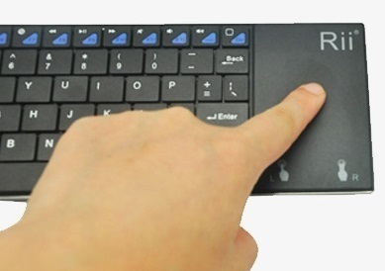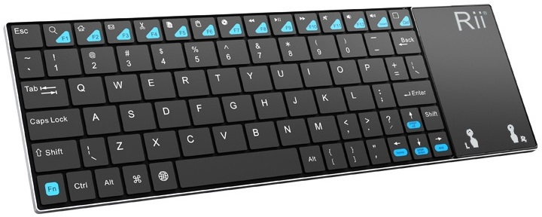

**Rii mini i28**

Breakthrough Creative design

Our Engineers have developed a classy, super-slim mini design that fits in your palm and delivers an instant feeling of quality.

High performance audio too!

Simply connect the earpiece to Rii mini i28 and you’re ready to enjoy your entertainment on the go or with your feet up! (earpiece is not provided).

Built in power pack

A non-detachable lithium battery is at the heart of the Rii mini i28 and rubber panels ensure non slip usage.

Soft silicon keys

2.4G wireless technology

Compatible with smart TVs, notebooks, desktop computers and HTPC

Works with Windows 2000, XP, Vista, Windows 7 and 8.

Backlit LED

High performance touchpad

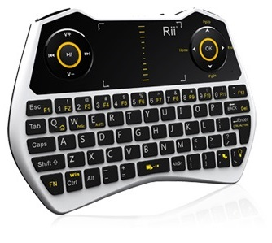 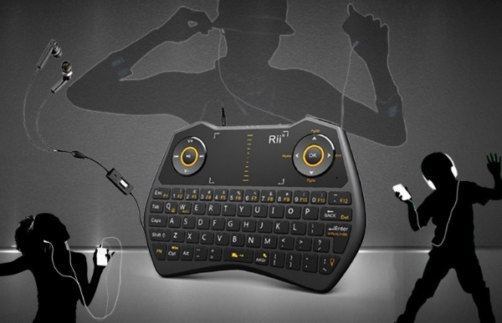 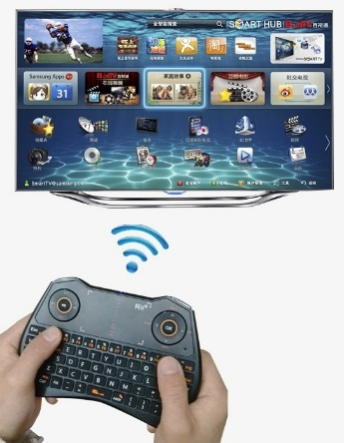

**Rii mini N7**

The amazing Rii mini N7 is a mini sized wireless keyboard compatible with computers, notebooks, and Smart TV. Use it to watch TV, surf the web, play games and more. It delivers reliability and durability for work and play.

N7 is the fashionable keyboard that works with Windows 7, 8 and XP. The plug and play USB receiver connects you with computers, notebooks and Smart TVs with no manual driver installation.

This little winder is palm and pocket friendly. Use it to watch TV, surf the web or work from anywhere!

The removable battery is placed in a unique chamber and can be charged with ease by the cable included.

Powerful reliable wireless 2.4G connection

10M distance connection

20 days standby power from fully charged battery

High performance touchpad replaces the mouse

Plug and play USB simplicity

